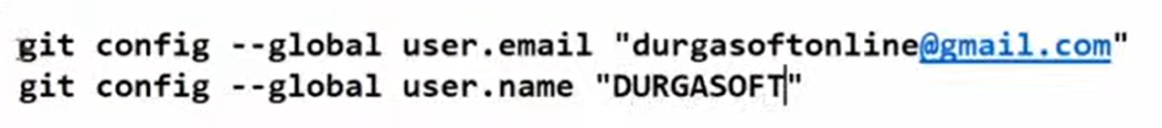





Staging area -> index area or cache area

Word count of commit id



First 3 -> owner permission

Second three -> user permission

Third three -> group permission

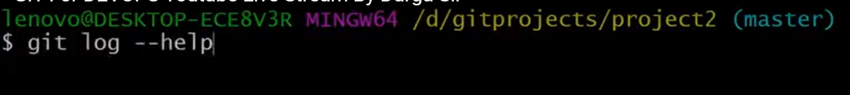

HEAD -> Most recent commit, HEAD is a reference to other reference, symbolic reference

Master/main -> is a branch name pointing to most recent commit

